

Artificial Intelligence (LAB)
Lab report 4

Submitted BY:
Wajahat Aftab
SU92-BSSEM-S25-002
BSSEM-4A

Submitted To:
Sir. Rasikh Ali

Task 01: Manual A* Expansion and Frontier Trace
Original Graph:
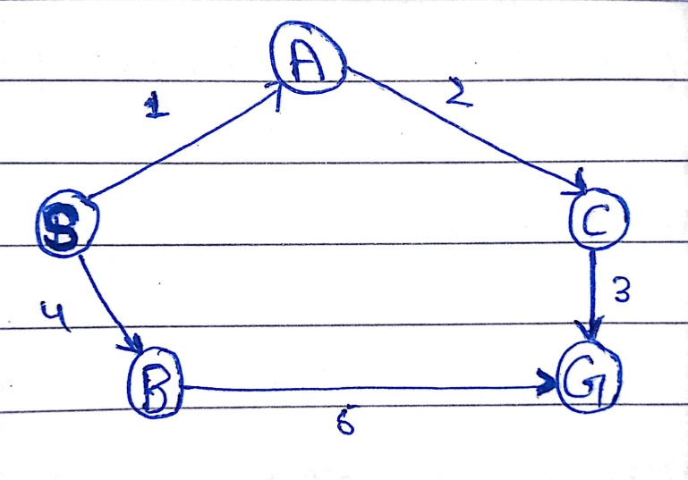

Evaluation Function:
f (n) = g (n) + h (n)
Expansion | Selected node | g(n) | h(n) | f(n) | Frontier after expansion | Why next node selected
1 | S | g (S) = 0 | h(S) = 5 | f(S) = 0+5 = 5 | A=(g=1, h=4, f=5); B:(g=4, h=4, f=8) | A  Because f(A)<f(B)
2 | A | g(A) = 1 | h(A) = 4 | f(A) =1+4=5 | C(g=3,h=2, f=5); B:(g=4, h=4,f=8) | C  Because f(C) <f(B)
3 | C | g(C) = 3 | h(C) = 2 | f(C) = 3+2=5 | G:(g=6, h=0, f=6); B:(g=4, h=4, f=8) | G  Because f(G) <f(B)

Successor Calculations:
Expansion1: S
- g(A) = 0 + 1 = 1
- f(A) = 1 + 4 = 5
- g(B) = 0 + 4 = 4
- f(B) = 4 + 4 = 8
Expansion2: A
- g(C) = 1 + 2 = 3
- f(C) = 3 + 2 = 5

Expansion3: C
- g(G) = 3 + 3 = 6
- f(G) = 6 + 0 = 6
Explanation:
Node with smallest cost (f(n)) will be selected. This is determined by the sum of the cost of the path taken to reach the node (g(n)) and the heuristic (h(n)). Firstly we will expand node S. we choose node A with a cost 5 in comparison to node B which has a cost of 8. Then we expand node A choosing node C with a cost of 5. Finally we expand node C we added node G to our frontier with a cost of 6. This is smaller than node B cost of 8 so we select node G.
Task 02: A* and UCS Search
Item | A* search | UCS Search
Heuristic | S: 5, A:4, B:4, C:2, G:0 | All values = 0
Returned path | S->A->C->G | S->A->CG
Independently summed path cost | 1+2+3 = 6 | 1+2+3 = 6
Processed node trace | S, A, C, G | S, A , C, B, G
Expansion count | 3 | 4
Explanation:
A* uses (f(n)=g(n)+h(n)), while UCS uses only path cost (g(n)). Both find the same path with a total cost of 6. A* expands S, A and C before reaching the goal. UCS also expands B because its path cost is 4, which is lower than the goal's cost of 6. The expansion count excludes the goal node, but the processed-node trace includes it. No stale entries occur in either run
Task 03: Effect of an Overestimating Heuristic
Item | Original Heuristic | Modified Heuristic
h(C) | 2 | 10
True remaining cost from C to G | 3 | 3
Returned path | S->A->C->G | S->B->G
Path cost | 1+2+3 = 6 | 4+5 = 9
Processed node trace | S, A, C, G | S, A, B, G
Expansion count | 3 | 3
Explanation:
The original value of h(C) is 2, while the true remaining cost from C to G is 3. The modified value of h(C) is 10, which overestimates the true cost. This makes the route through C appear less promising, so A* selects the route through B and returns a path cost of 9 instead of 6. An overestimating heuristic can remove A*'s guarantee of finding the optimal path

